To run this project double click on ‘run.bat’ file to get below screen

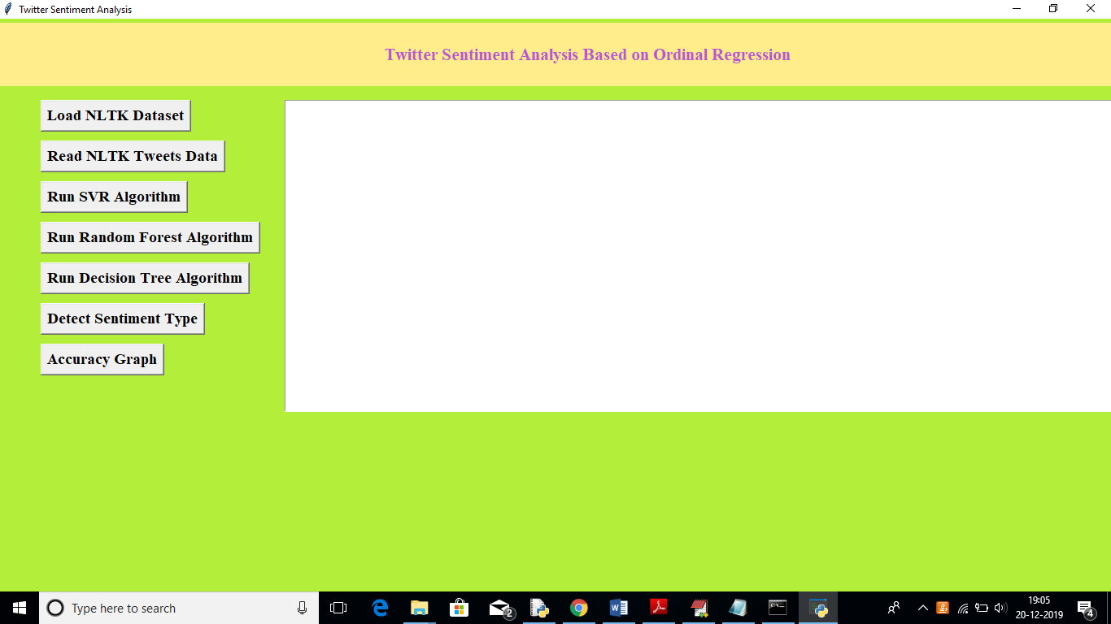

In above screen click on ‘Load NLTK Dataset’ to load tweets dataset from NLTK library

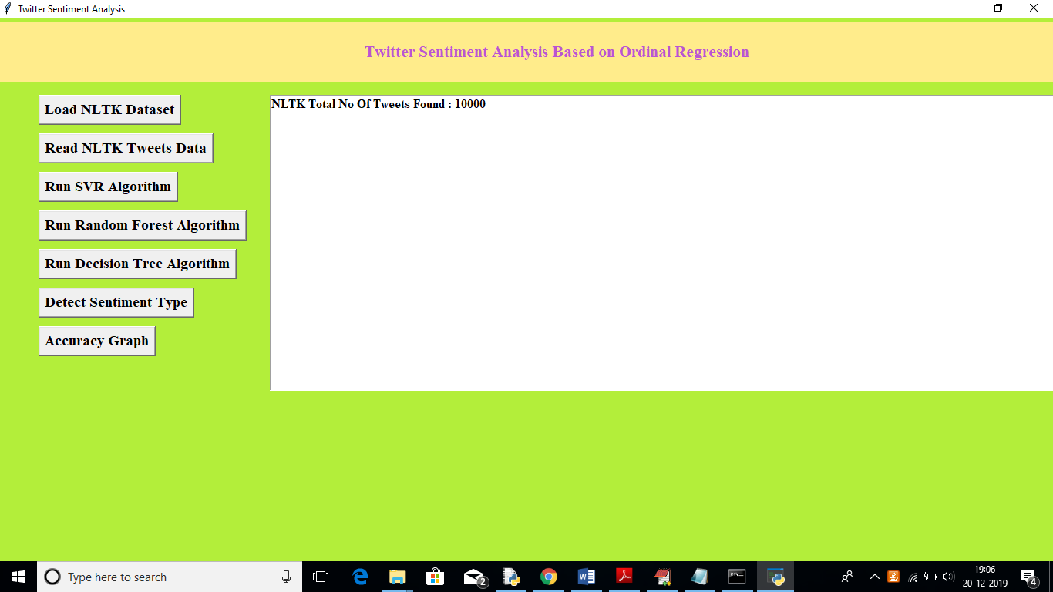

In above screen we can see total 10000 tweets are there in NLTK library, now click on ‘Read NLTK Tweets Data’ button to read all tweets and to build TFIDF vector. Upon each button click you need to wait for some seconds to get output. See below screen

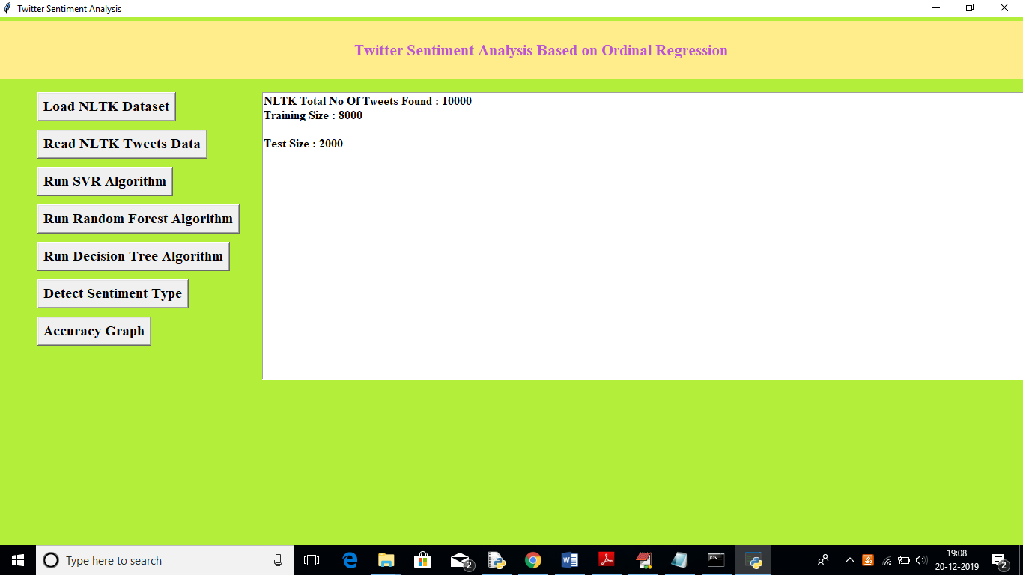

In above screen we can see total 8000 tweets vector used for training purpose and 2000 tweets used for testing purpose. Now click on ‘Run SVR Algorithm’ to build train model on that dataset and to calculate accuracy

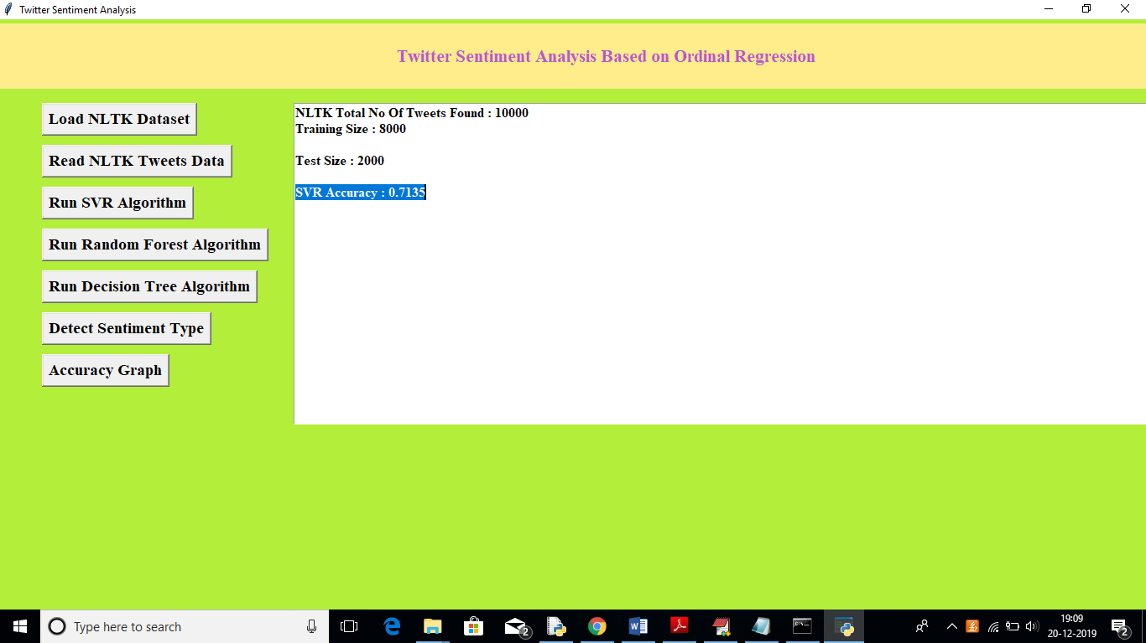

In above screen we can see SVR generate 0.71% prediction accuracy, now click on ‘Run Random Forest Algorithm’ button to calculate its accuracy

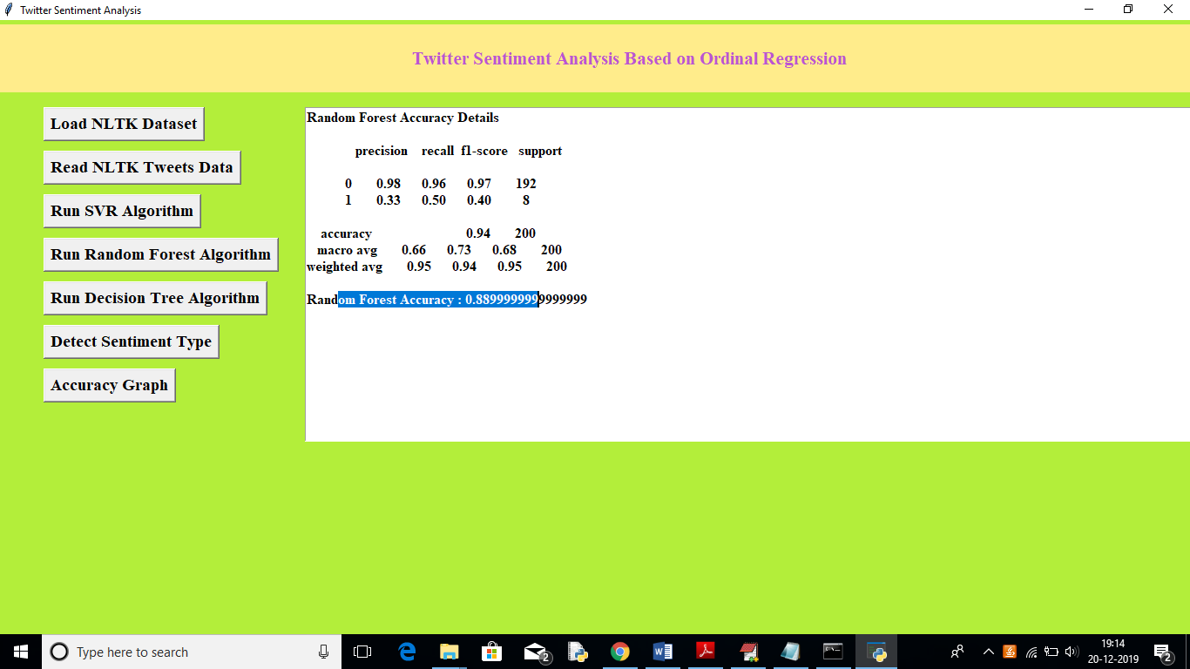

In above screen Random Forest got 0.88% accuracy, now click on ‘Run Decision Tree Algorithm’ button to calculate its accuracy

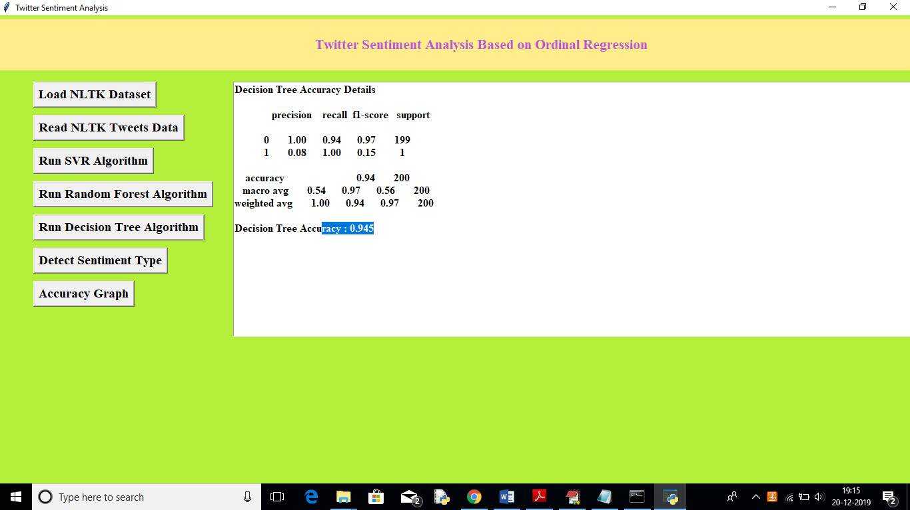

In above screen Decision Tree got 0.94% accuracy, Now click on ‘Detect Sentiment Type’ button and upload test tweets to predict it sentiment. In test folder inside test.txt you can see there is no sentiment label and application will detect it.

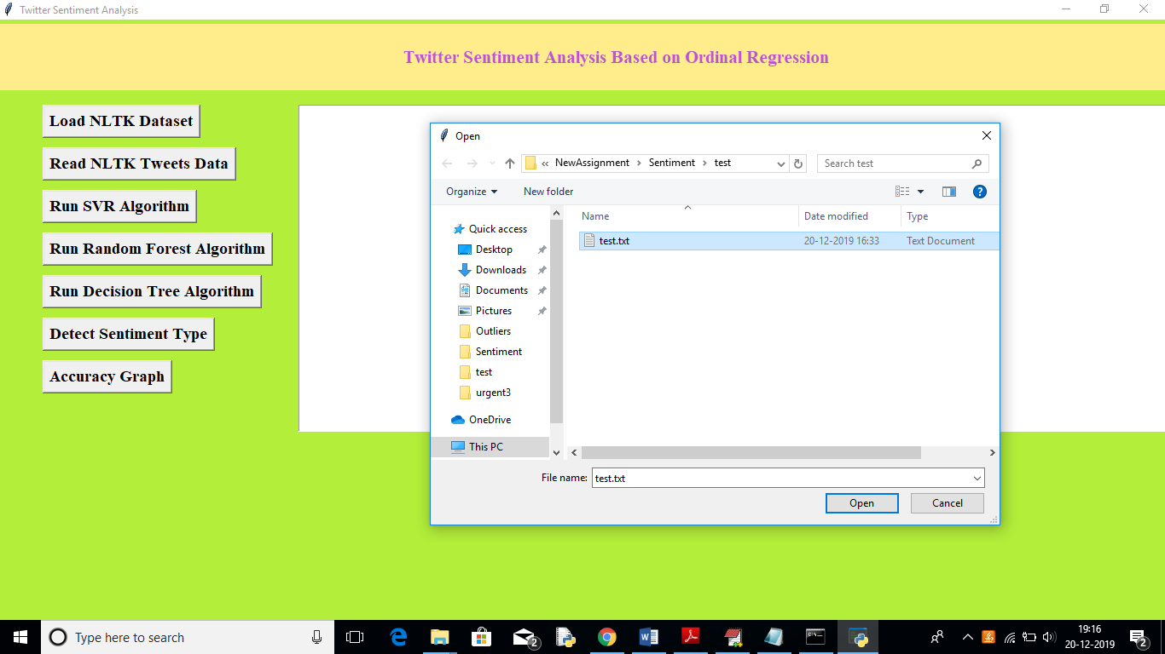

In above screen uploading test tweets file and below are the prediction results

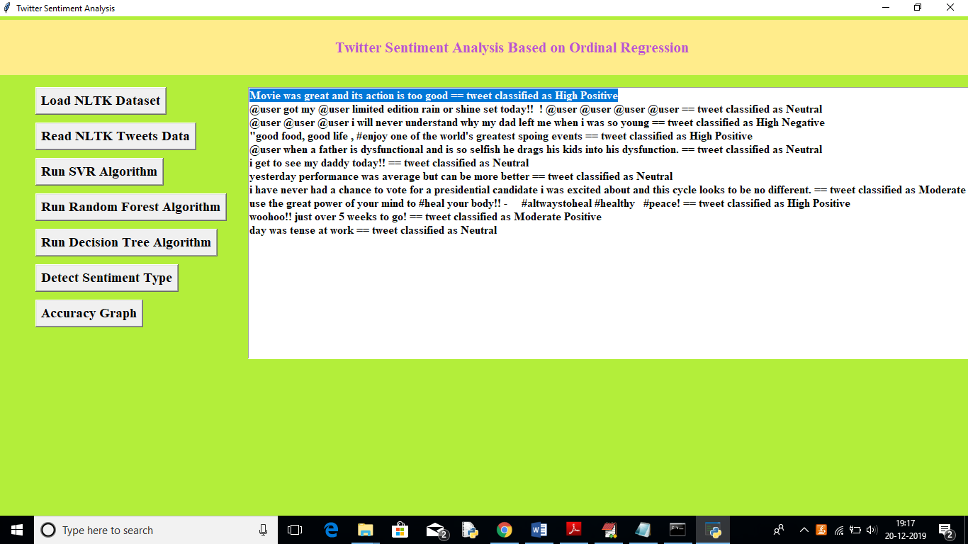

In above screen for each tweet we can see the classified/predicted sentiments. Now click on ‘Accuracy Button’ to get below accuracy graph

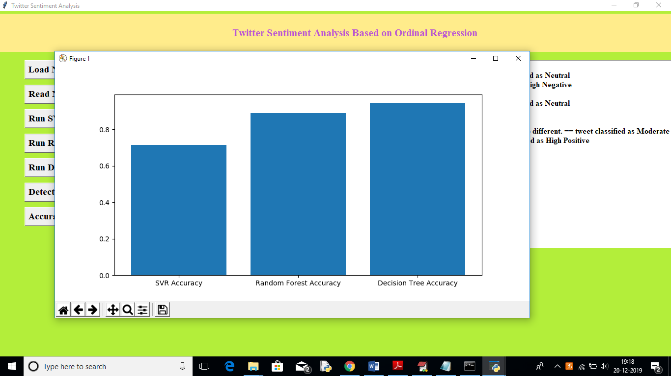

In above graph x-axis represents algorithm name and y-axis represents accuracy, from above graph we can see decision tree got better prediction compare to other algorithm.

In this paper author using another algorithm called SOFTMAX but its not a classifier algorithm, so I am not implementing it